How to use the Arrow Count feature in ArcherySuccess to record unscored arrows

The features enabled by the arrow count/blank bale journal entry are as follows:
- bulk record unscored arrow count,
- keep track of arrow count during a training session
- record notes about the training session

To bulk record unscored arrows count, tap on the number between the + and – buttons, and enter the arrow count on the keyboard; for example, you’ve shot 72 unscored arrows, but you haven’t recorded it in the app yet, use this feature to quickly enter the total count.
To keep track of arrow count during a training session, use the + and – buttons to add the number of arrows indicated on the Arrow Count slider. The number on the arrow count slider should equal the number of arrows you shoot per end, e.g. If you shoot 6 arrows per end, the arrow count slider should be set to 6, which means you can press the + button to add 6 to your total count every time you’ve completed an end. Pressing the – button will remove arrow count.
To record notes about the training session, type the notes in the fields provided, the notes entered will also be reflected in the progress report.
A reminder timer feature on the Arrow Count page indicates the last time the total arrow count number was updated. This feature is handy when you get distracted after completing an end and can’t remember if you’ve already added the arrow count, for example if the timer indicates 30 seconds, it means the last time you’ve added arrow count was 30 seconds ago. If no time is indicated, it means you’ve just opened the journal entry and the timer has reset.
The way I use the arrow count feature is to leave my phone on the Add Arrow Count page. After each end, I unlock my phone and tap + to add the arrow count indicated on the slider. As I walk to the target to retrieve my arrow, I also update my notes about the last end.
See the rest of this document on how to use the feature.

The Arrow Count feature can be found on the Journal Tab, under the  icon in the top right corner of the page.
The following screenshot shows the Journal Page; tap the icon in the right top corner to display the Add Journal Entry menu items.
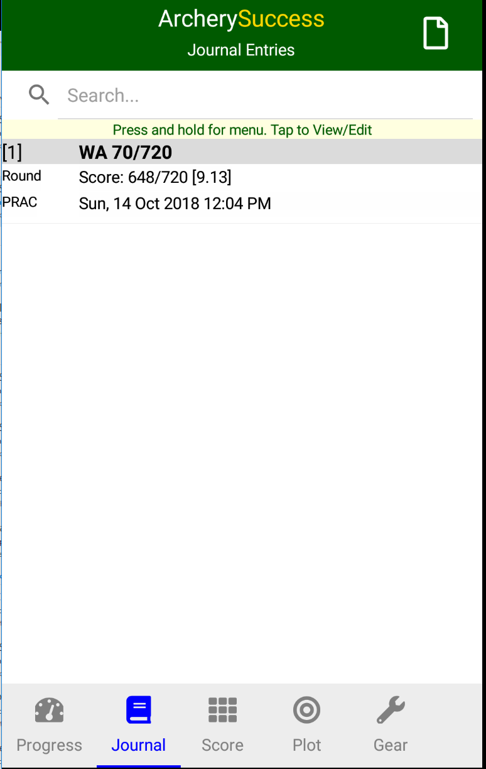

On the Add Journal Entry menu items, tap the Arrow Count (Count) item to display an Add Arrow Count Page.
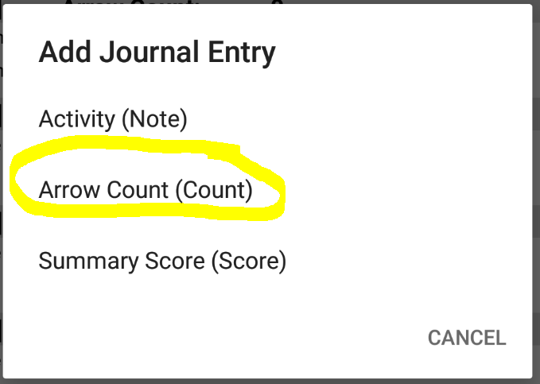

On the Add Arrow Count page, session notes can be entered as well as Add/Remove Arrow Count.
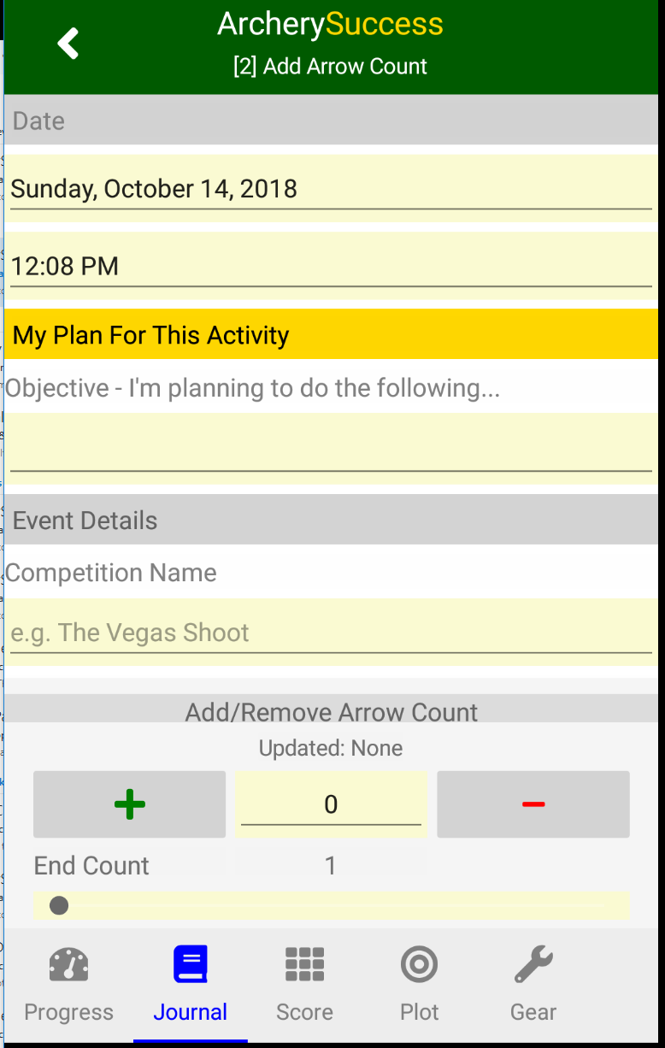
To record arrow count for an end, slide the End Count slider to the number of arrows shot in the end and then tap the + button. This will add the number of arrows indicated on the End Count slider to the total arrow count which is displayed between the + and - buttons.
Pressing the – buttons will subtract the End Count slider number from the total arrow count (the number between the + and – buttons)
Pressing the + or – buttons will also start a reminder timer to show when last arrow count was added or deleted. This feature is handy for those times when you get distracted after completing an end and can’t remember if you’ve already added the arrow count, for example if the timer indicates 30 seconds, it means the last time you’ve added arrow count was 30 seconds ago. If no time is indicated, it means you’ve just opened the journal entry and the timer has reset. The count will stop when it reached 5 minutes, which means the last arrow count update were done more than 5 minutes ago.
In the following example the End Arrow Count is 6
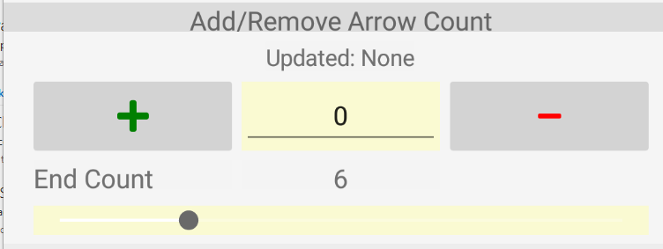
Pressing the + button adds the 6 arrows to the count and starts a timer to indicate how long ago the count was added. The timer feature assists with remembering if arrow count has been added.
